**Circuit Simulation Project**

[**https://esim.fossee.in/circuit-simulation-project**](https://esim.fossee.in)

**Name of the participant : Nunna Lakshmi Saranya**

**Title of the circuit : 2 bit multiplier**

**Theory/Description :** A multiplier is a [combinational logic circuit](https://technobyte.org/sequential-combinational-logic-circuits-types/) that we use to multiply binary digits. Just like the adder and the subtractor, a multiplier is an arithmetic combinational logic circuit. It is also known as a binary multiplier or a digital multiplier.

Binary multiplication works just like normal multiplication. There are four main rules that are quite simple to understand.

0*0=0

0*1=0

1*0=0

1*1=1

**Circuit Diagram(s) :**

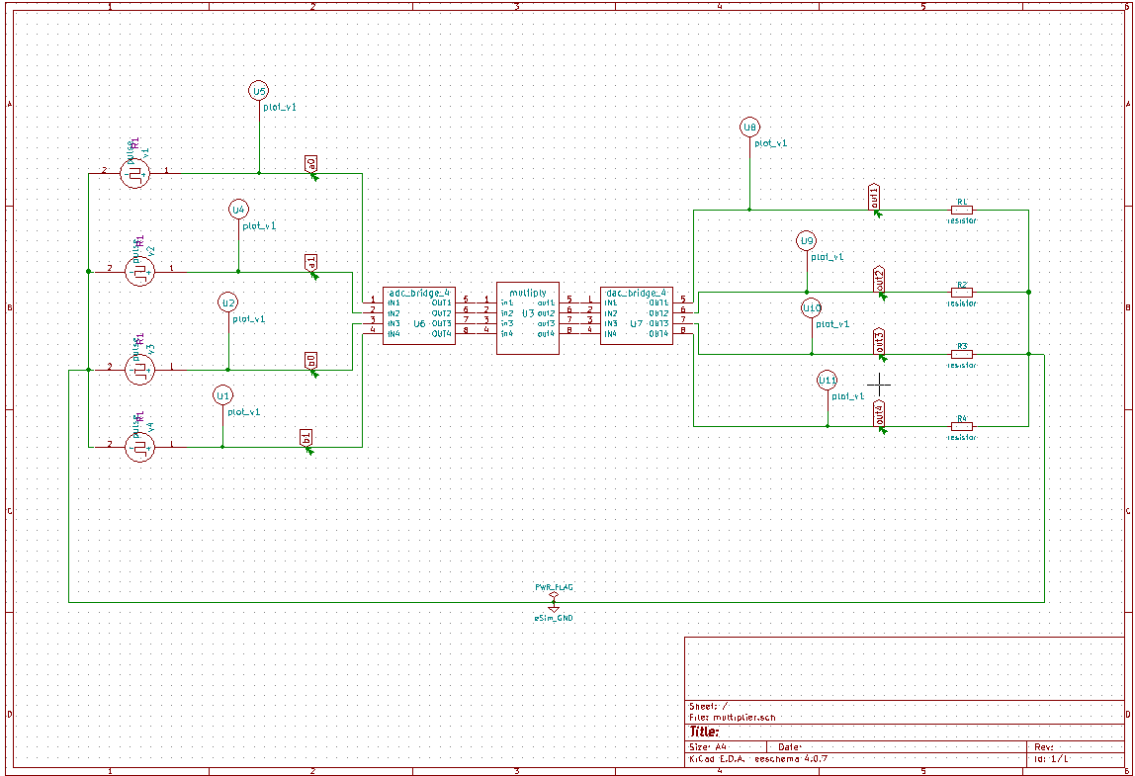

**Results (Input, Output waveforms and/or Multimeter readings) :**

**Input (a) -**

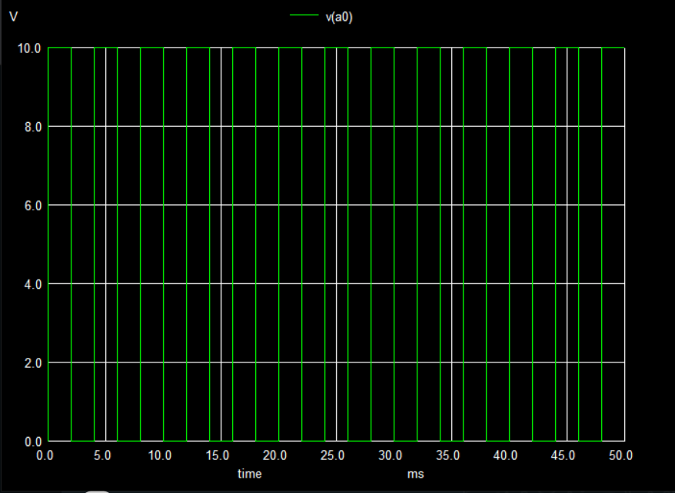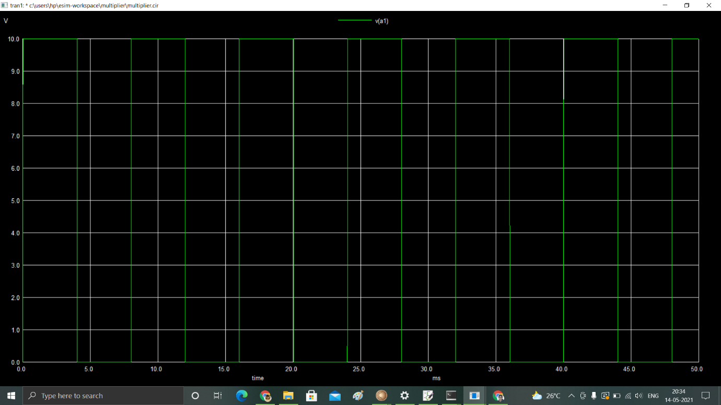

**Input (b) -**

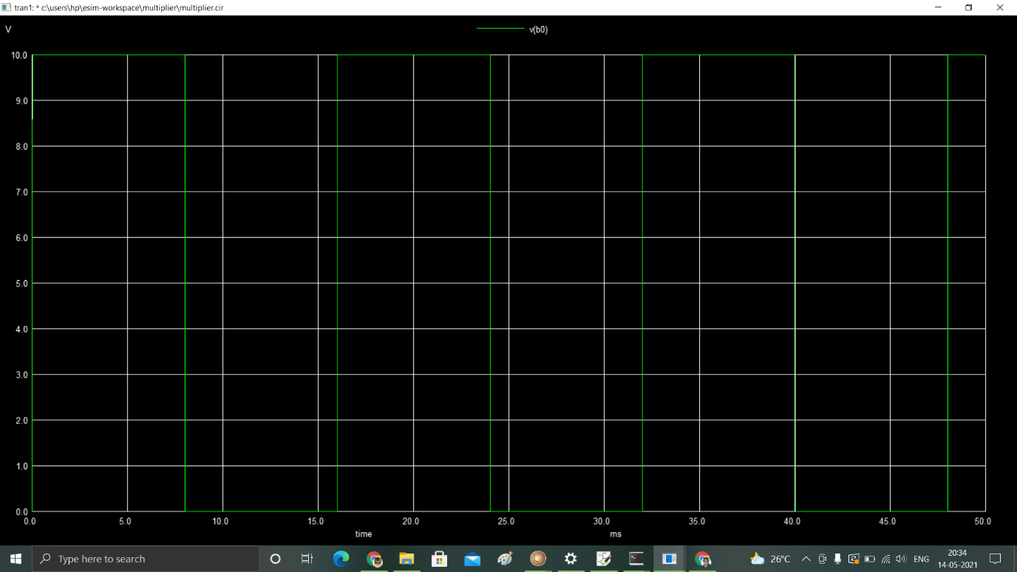

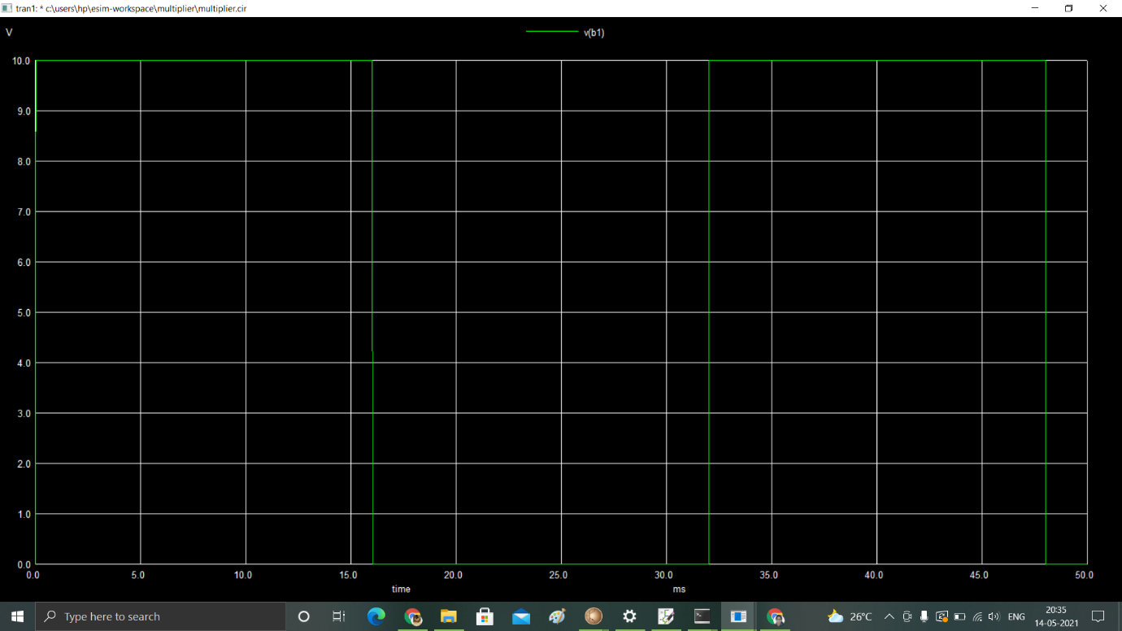

**Output waveforms-**

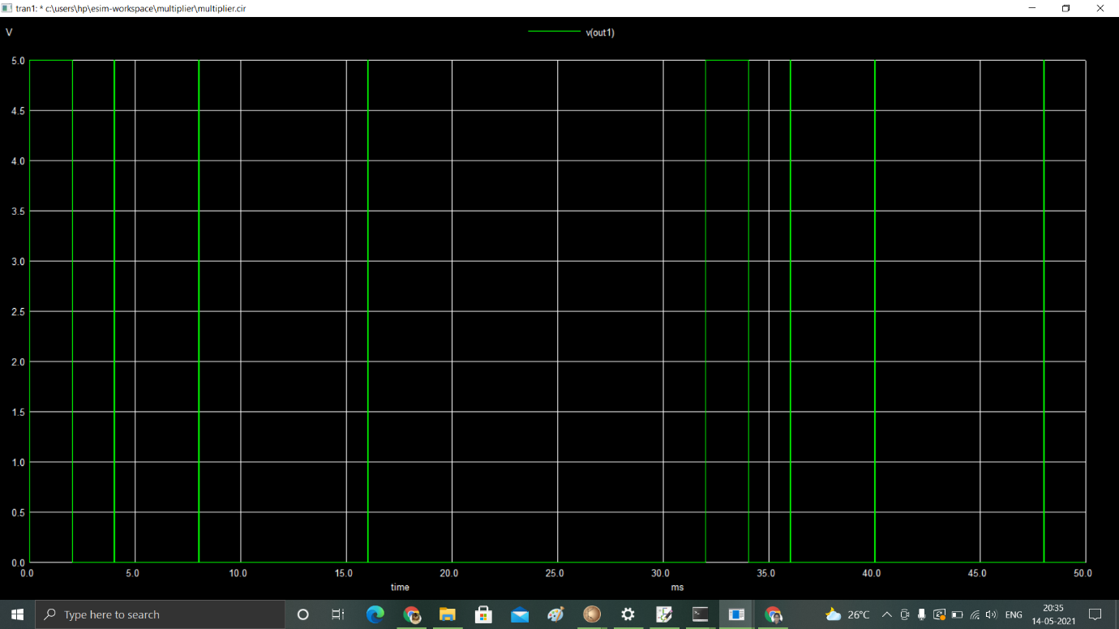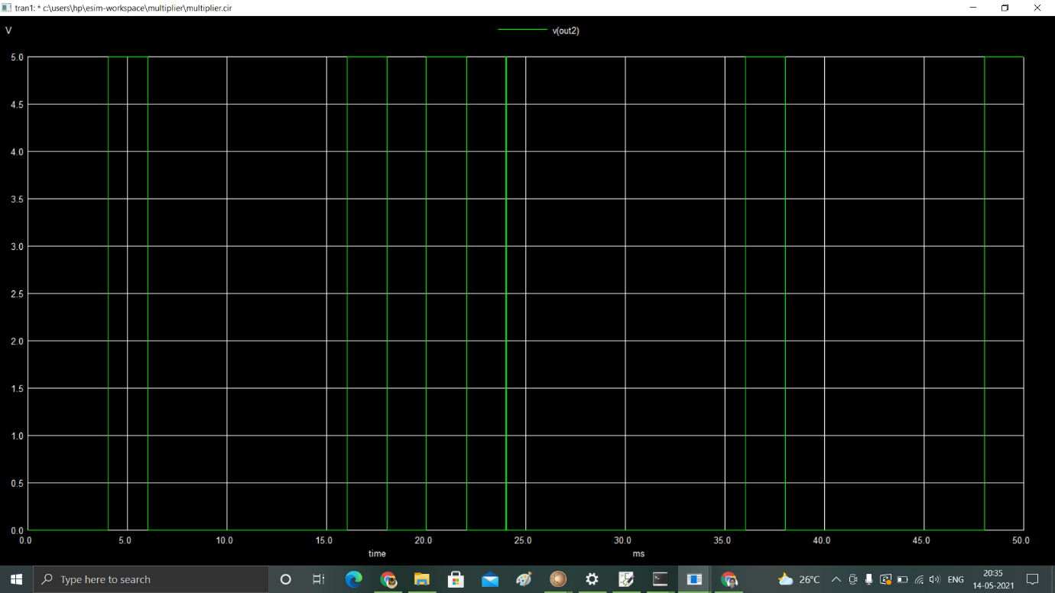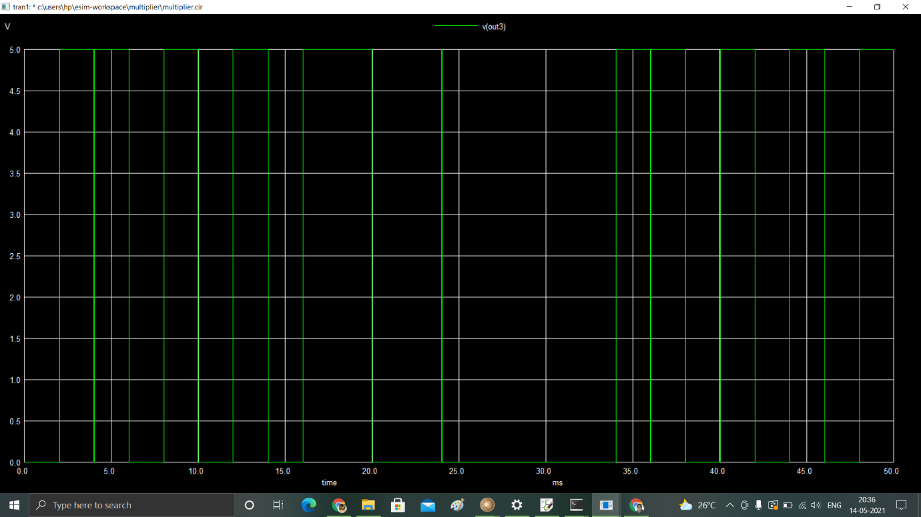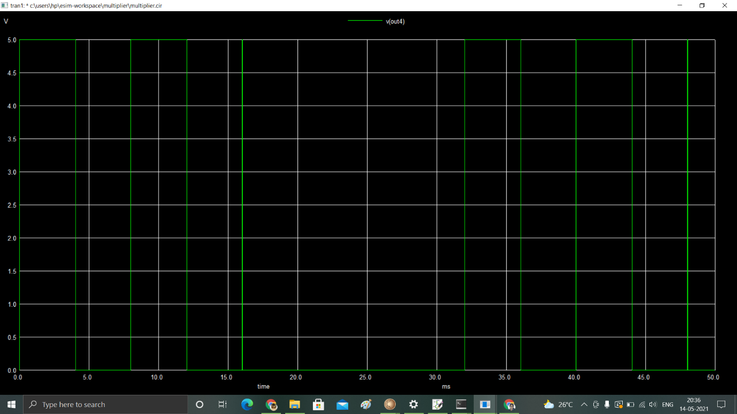

**Python plots-**

**Input a -**

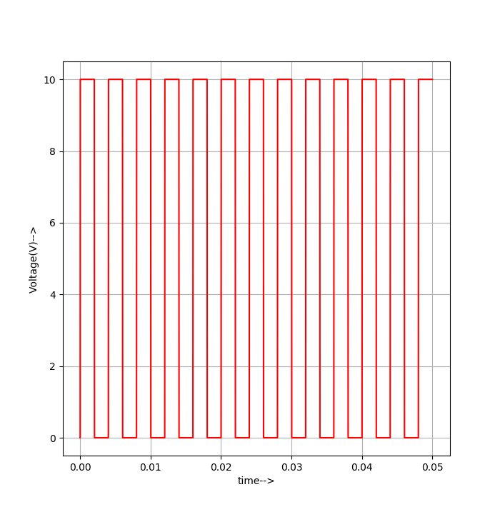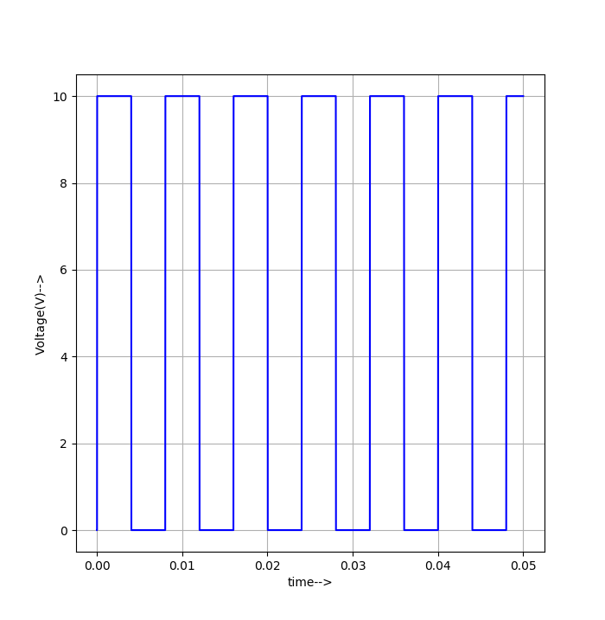

**a[0] a[1]**

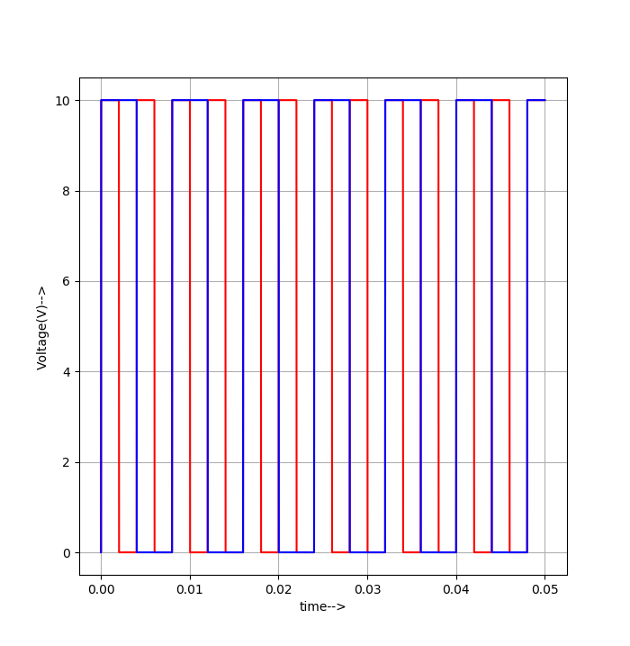

**a0 & a1**

**input b -**

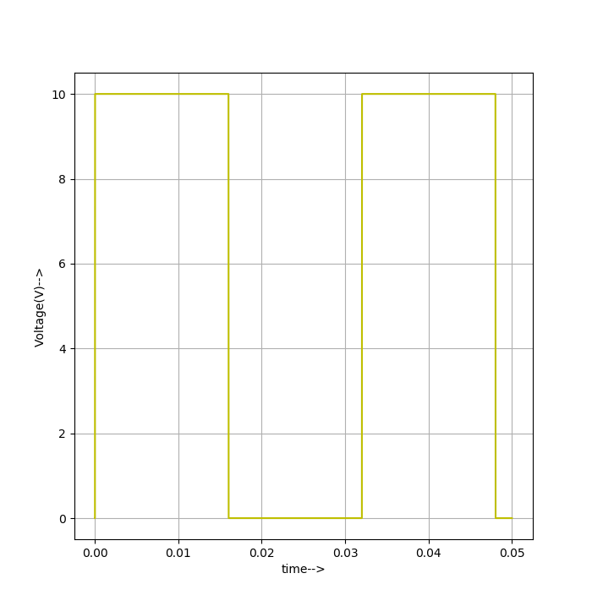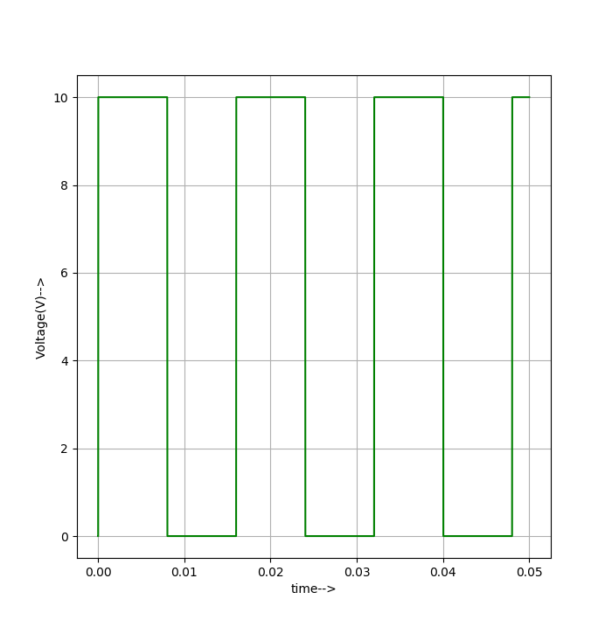

**b[0] b[1]**

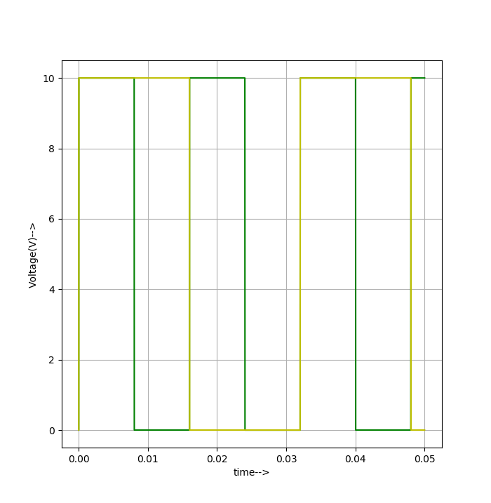

**Input b (b0 &b1)**

**Output plots-**

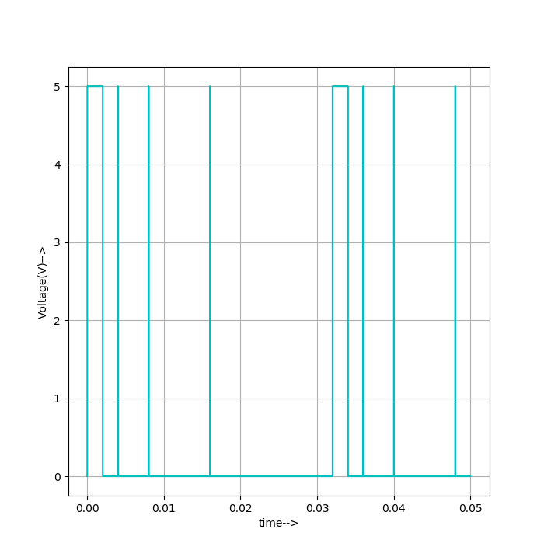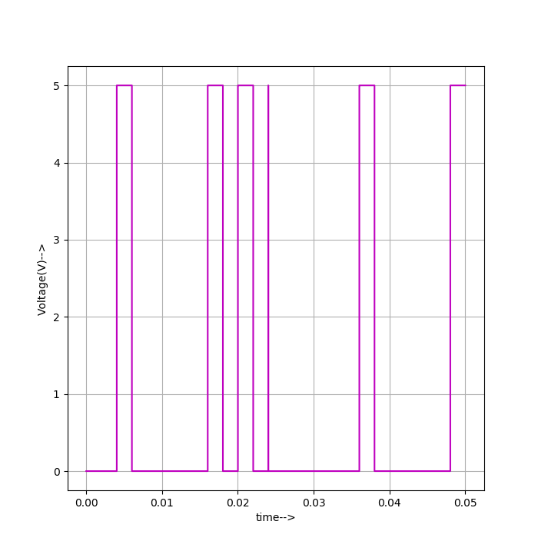

**Out[0] out[1]**

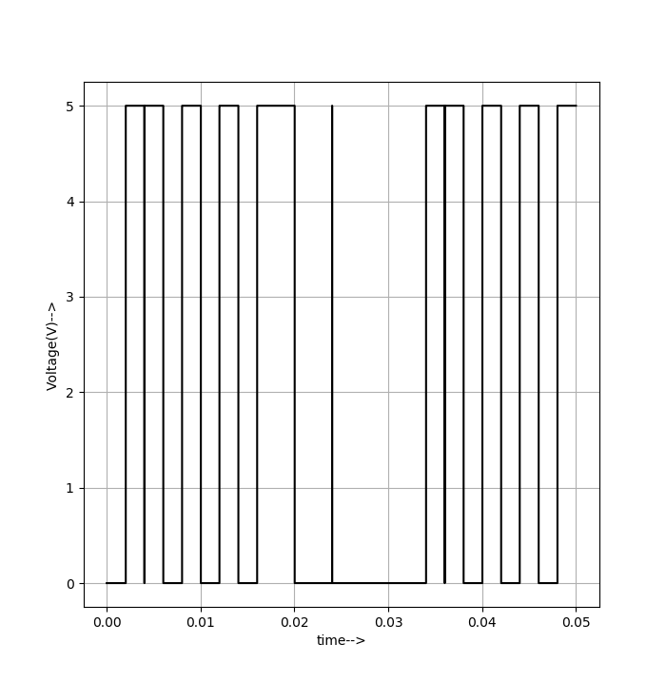

**Out[2] out[3]**

**Table-**

|  |  |  |  |  |  |  |  |  |
| --- | --- | --- | --- | --- | --- | --- | --- | --- |
| A0 | A1 | B0 | B1 |  | O1 | O2 | O3 | O4 |
| 0 | **0** | **0** | **0** |  | **0** | **0** | **0** | **0** |
| 0 | **0** | **0** | **1** |  | **0** | **0** | **0** | **0** |
| 0 | **0** | **1** | **0** |  | **0** | **0** | **0** | **0** |
| 0 | **0** | **1** | **1** |  | **0** | **0** | **0** | **0** |
| 0 | **1** | **0** | **0** |  | **0** | **0** | **0** | **0** |
| 0 | **1** | **0** | **1** |  | **0** | **0** | **0** | **1** |
| 0 | **1** | **1** | **0** |  | **0** | **0** | **1** | **0** |
| 0 | **1** | **1** | **1** |  | **0** | **0** | **1** | **1** |
| 1 | **0** | **0** | **0** |  | **0** | **0** | **0** | **0** |
| 1 | **0** | **0** | **1** |  | **0** | **0** | **1** | **0** |
| 1 | **0** | **1** | **0** |  | **0** | **1** | **0** | **0** |
| 1 | **0** | **1** | **1** |  | **0** | **1** | **1** | **0** |
| 1 | **1** | **0** | **0** |  | **0** | **0** | **0** | **0** |
| 1 | **1** | **0** | **1** |  | **0** | **0** | **1** | **1** |
| 1 | **1** | **1** | **0** |  | **0** | **1** | **1** | **0** |
| 1 | **1** | **1** | **1** |  | **1** | **0** | **0** | **0** |

**Source/Reference(s) :**

[**https://technobyte.org/multiplier-2-bit-3-bit-digital**](https://technobyte.org/multiplier-2-bit-3-bit-digital)